Group 2
Lê Tuấn Huy
Vũ Huy Chris
Đỗ Khắc Phi
Nguyễn Đình Tùng Dương
Nguyễn Đăng Nhật Minh
Nguyễn Đăng Tuấn Minh

Preserving Hmong Cultural Heritage In Ha Giang Through Smart Technologies
June 18, 2025

Part A:

1 Introduction

1.1. Overview

This project seeks to conserve the valuable cultural heritage of Vietnam's H'Mông people of Hà Giang province by means of sustainable, innovative, and community-based solutions. To achieve this, the project provides an integrated set of measures to address a core element of cultural preservation. These are promotion of sustainable models of cultural tourism, restoration and conservation of cultural artifacts, and revival of the H'Mông language and traditional stories. All the strategies are formulated through consultation with local residents and feature appropriate technologies to ensure the solutions are environmentally sustainable and culturally respectful, and acceptable to local conditions.

1.2. Object
- Hmong people/community in Ha Giang province, Vietnam.
- Population (2019): ~290,000 (31,9% of the entire population of Ha Giang province and 21,7% of the entire Hmong population in Vietnam).

1.3. Identified problem: Culture Preservation in modern context.
In today’s rapidly globalizing world, many minority cultures face the risk of being lost or forgotten. This is the problem of Culture Erosion, or simply, The Loss of Culture.
The H'Mông language, along with its oral traditions, customs, and stories, is at risk due to limited intergenerational transmission, migration, and the dominance of national or global languages like Vietnamese and English. Younger generations are often not fluent in their native tongue, and the lack of accessible resources or tools makes it difficult to learn or use the language in daily life.
Moreover, traditional forms of preserving culture—such as handwritten texts, songs, and oral stories—are often inaccessible, non-digitized, or undocumented. Without active measures, these valuable cultural elements may disappear. There is a clear need for modern, digital tools that can preserve, teach, and revitalize endangered languages like H'Mông while also making them usable in practical, everyday settings such as education, healthcare, tourism, and communication.
This problem highlights the urgent need for a solution that bridges cultural preservation with digital technology, ensuring that the H'Mông language and culture continue to thrive in the modern context.
That is the challenge we will tackle in this report, Culture Preservation, to fight against The Loss of Culture.

1.4. Goal.
- Preserve and Protect Hmong Cultural Heritage: Protect both physical cultural assets (such as traditional clothing, tools, and sites) and intangible heritage (such as language, rituals, and stories) from being lost to modernization, migration, and generational change.
- Leverage Modern Technology for Cultural Documentation and Revitalization: Use innovative tools like 3D scanning, digital storytelling, and translation apps to accurately capture, store, and share Hmong cultural elements in accessible and engaging formats.
- Promote Intergenerational and Public Cultural Education: Bridge the gap between elders and youth, and increase cultural awareness among non-Hmong communities through educational platforms, digital media, and immersive experiences.
- Support Sustainable Economic Development through Cultural Tourism and Creative Industries: Enable Hmong communities to earn sustainable incomes by engaging in tourism, traditional embroidery, and digital crafts in ways that protect, rather than exploit, cultural values.
- Foster Community Ownership and Inclusive Participation: Ensure that all preservation strategies are co-created with the Hmong people, respecting their customs and giving them control over how their culture is represented and shared.
- Create Long-Term, Adaptable Models for Indigenous Cultural Preservation: Develop ideas that can be maintained by the community, scaled to other villages, or used as models for preserving other minority cultures..

Part B:
Our design ideas

3.1. Design Idea 1: Sustainable Tourism
- Team Member Lead: Lê Tuấn Huy
Description
- A community-centered sustainable tourism platform aimed at preserving the Hmong cultural heritage in Ha Giang by integrating digital technology, community participation, and eco-friendly tourism infrastructure.
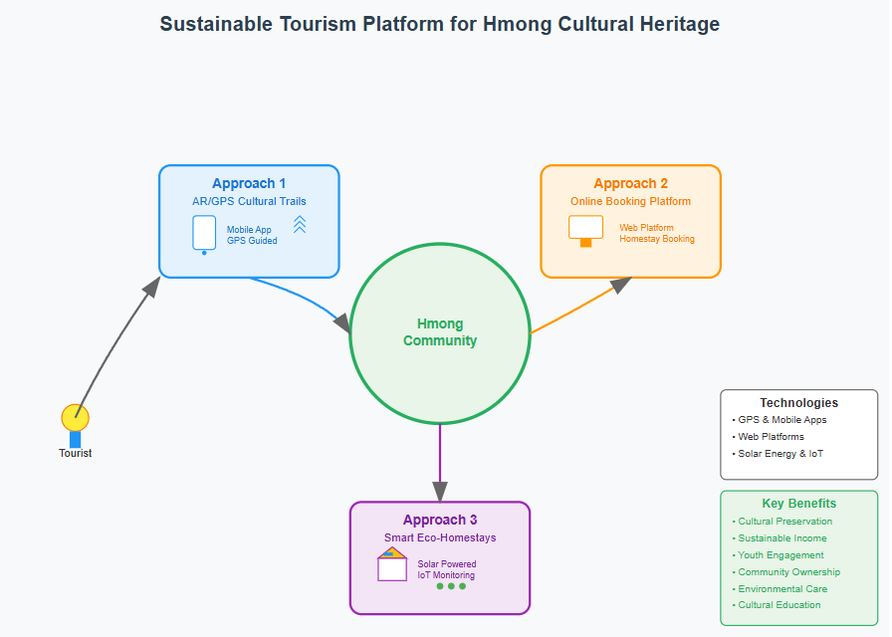
Design Specification
Approach 1: Enhancing tourist learning experiences through guided AR/GPS storytelling trails
- Technology: GPS-based mobile application that guides tourists through curated cultural trails.
- Devices: Smartphones, GPS Receiver.
Approach 2: Streamlining access to homestays and services for guests & hosts
- Technology: Online Booking and Resource Management System.
- Devices: Smartphones (Client), Servers (Host)
Approach 3: Making homestays eco-efficient, tech-enabled, and self-sufficient.
- Technology: Renewable-Powered Smart Homestay Ecosystem
- Devices: Solar Panels and Inverters, IoT Devices (e.g., Raspberry Pi, Arduino, Sensors).
Hardware/Software requirements:
Hardware:
- Smartphones: For tourists to interact with services.
- GPS Receiver: Used by community guides to manage and update trail data.
- Servers: Manages tourists’ info.
- Solar Panels and Inverters: Energy to power smarthomes.
- IoT Devices (e.g., Raspberry Pi, Arduino, Sensors): Monitoring energy, water, and waste usage in homestays.
Software:
- Mobile app for cultural trails (iOS/Android).
- Web-based booking and management platform.
Functionality:
- Tourists use a mobile app to follow GPS-guided cultural trails enriched with multimedia content. They can book eco-friendly homestays through a local online platform. Homestays are powered by solar energy and equipped with IoT systems to monitor and manage resources efficiently. The system ensures cultural immersion, economic empowerment, and environmental sustainability.

Benefits of design idea
Benefits of the design:
- Sustainable Income Generation: Direct economic benefits for Hmong families through homestays and guided tours.
- Cultural Education: Tourists gain a deeper, respectful understanding of Hmong traditions and values.
- Community Empowerment: Local ownership and participation foster pride and long-term cultural stewardship.
Impacts:
- Cultural Preservation: The community gains tools to protect and share their heritage on their own terms.
- Youth Engagement: Young Hmong people are involved in tech, tourism, and environmental initiatives, making traditions relevant to their future.
- Environmental Conservation: Smart homestays reduce ecological footprints and promote sustainable living practices.
Cultural/environmental appropriateness:
- The design respects traditional Hmong architecture and cultural practices. It uses natural materials and involves the community in storytelling and tourism management, ensuring authenticity and cultural sensitivity.

Community benefits in accordance with the guidelines:
- Access & Equity: Inclusive mobile app and booking system for all users. Biradar (2024) states that "Digital technology further enhances tourism opportunities by enabling Indigenous businesses to reach wider audiences, market their services, and educate travelers about responsible engagement with Indigenous cultures.” which speaks to the increased accessibility of their offerings and supports the "fairness" aspect by reducing intermediaries and allowing direct control and revenue generation.
- Health & Safety: Eco-friendly accommodations often prioritize the use of natural, non-toxic building materials (like FSC-certified wood, bamboo, rattan) and natural cleaning products. This significantly enhances indoor air quality by reducing volatile organic compounds and other harmful chemicals commonly found in conventional establishments, benefiting guests' respiratory health and overall well-being. (Worldpackers, 2025)
- Appropriateness: Tailored to Hmong cultural and environmental context. According to Vietnam Discovery (2021), Hmong people's rammed-earth houses, built with thick, compacted earth walls and often featuring tile or thatch roofs, are a distinctive cultural feature in Ha Giang, well-suited to the mountainous environment.
- Affordability: Long-term cost savings through renewable energy and local ownership. According to Gall (2018), investing in renewable energy, such as solar power, directly leads to lower energy bills for households and businesses over the long term. Once the initial investment is recouped, communities benefit from significantly reduced operational energy costs.
- Environmental Health: Use of solar energy and natural materials. Trinh T. T. T. A., Trinh T. T. L. A., and Thanh (2023) found that the integration of solar energy aligns with green tourism practices that encourage the use of renewable energy sources for accommodations and facilities.
- Sustainable Livelihoods: Community-led tourism and tech-based income generation. The 2024 UNWTO conference in Vietnam highlighted tourism as a key driver of rural empowerment, job creation, and cultural preservation. (UN Tourism, 2024)

Constraints of design idea:
- Digital Literacy and Infrastructure Gaps: Some community members may need training and improved internet access.
- High Initial Costs: Installing solar and IoT systems may be financially challenging for low-income households.

3.2. Design Idea 2: Preserving H’Mong Embroidery Through Digital Tools and Cultural Empowerment
- Team Member: Nguyen Dinh Tung Duong
Description
- The aim is to preserve and revive traditional H’Mong embroidery with machine age technology running interfering with common folk cultural practices. At the core of the design lies a hybrid platform of a mobile learner application, a digital pattern archive, offline-access devices, and local-market apparatus. This facilitates knowledge transfer from the elders to the youth, empowers the artisans, and remunerates them on a sustainable basis. The app allows digitization in both H’Mong and Vietnamese with video tutorials, documentaries of embroidery processes, and economic links.

The design also fosters community participation through cultural workshops that broker intergenerational conversations with an emphasis on pride in the culture. They create structured multimedia experiences for learning and economic independence to resolve cultural erosion and economic challenges simultaneously. The community is even incentivized to take ownership through user-generated content and joint-access devices generously distributed to schools and cultural centers.

The approach is low-cost, scalable, and fit for application in the local setting, making this design a sustainable mode.

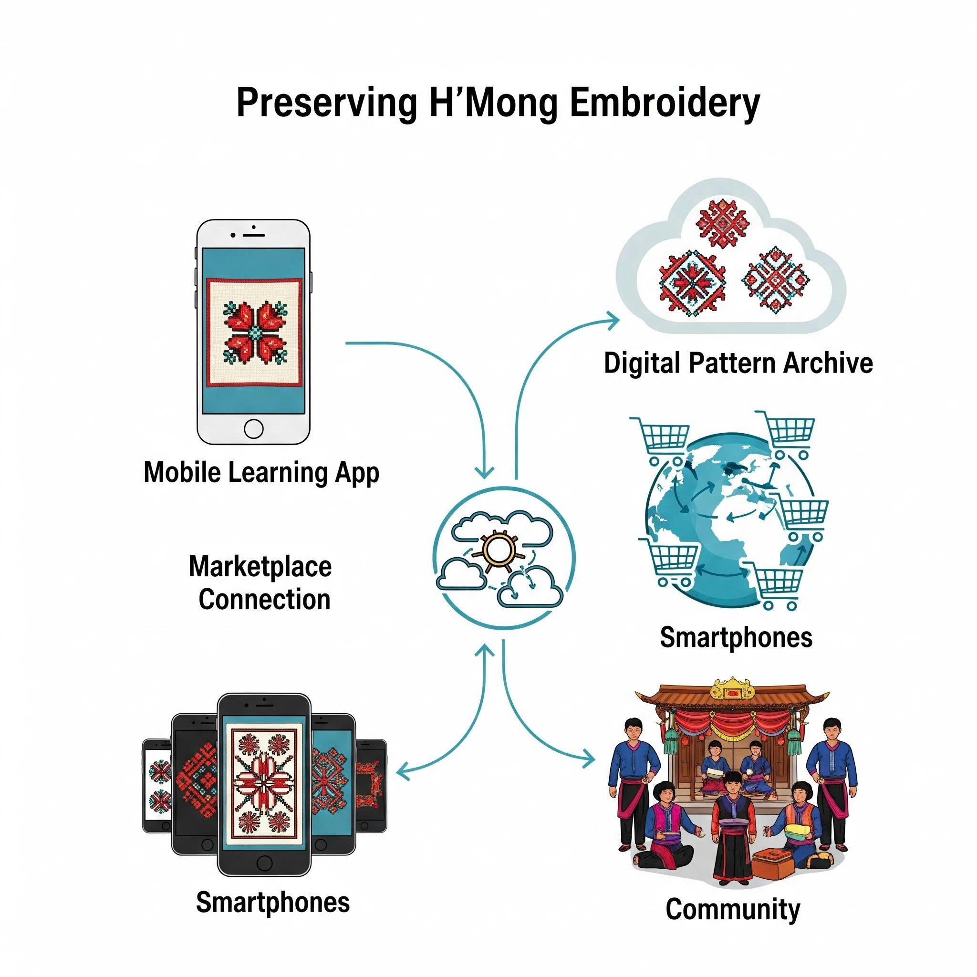

Design Specifications
Approach 1: Document and Understand Cultural Decay
- Technology: Digital Pattern Archive:
Gathering and archiving embroidery patterns, explanations and documentation in the forms of video demonstration. This assures our learning is preserved long term and accessible by entire generations.
- Devices: Android Smartphones, Tripod and Light Kit.
Approach 2: Reviving Culture Through Education and Engagement
- Technology: Mobile Learning App:
Promoting an interactive education on stitching while counting on bi/multi-lingual instruction (H'Mong, Vietnamese) and an outline learning pathway containing instructional videos in order to revitalize interest in embroidery in younger generations and including accessibility of how and when to learn the instruction of their choice.
- Devices: Tablet or Raspberry Pi Viewer, Traditional Sewing Materials.
Approach 3: Embed Culture Into Sustainable Future Systems
- Technology: Marketplace Connectivity:
An extensive e-commerce opportunity to communicate traditional products from our embroidery into a NGO logging frame and ethical fashion brands ensuring multiple cultural and economic opportunities into the long term.
- Devices: Android Smartphones, Tablet or Raspberry Pi Viewer.

Hardware/Software Requirements:
- Hardware:
  - Android smartphones (for video recording and mobile app).
  - Tripod and LED light kit (to support video quality).
  - Raspberry Pi or tablet (for accessing offline content).
  - Locally sourced materials for embroidery (fabrics, needles, thread).
- Software:
  - Mobile app that supports the H'Mong/Vietnamese languages.
  - Embedded video tutorials, archive search, and offline mode.
  - Marketplace integration (for artisan product sales).
  - Cloud storage or local database (pattern repository).

Functionalities:
Elders will use the Android smartphone with tripod setup to record their demonstrations of the embroidery, in lighting appropriate for their demonstration. They will upload the recordings, either as videos and pattern notes to the app or to a Raspberry Pi, so it can be used offline. Young people and artisans will be able to learn from and engage in cultural activities through the app. They will also be able to upload and sell their products through a marketplace option. The archive will continue to expand, and be a resource for learning and continue to hold value in preserving culture.

Benefits of the Design Idea
- Education and Skills Transmission:
Retains expert knowledge of embroidery and several of its specialist practices in a way that enables younger generations to engage with and understand.
- Cultural Revitalization:
Restores pride and value in H’Mong identity; digital innovation integrated with versions of traditional craft.
- Income Generation:
Allows artisans to sell products online and sustain their lives through cultural work and practices.

Community Impacts
- Youth Empowerment:
Enables youth to engage with their ancestry in powerful ways in order to build traditional skills and digital literacy.
- Community-Led Conservation:
Promotes locals as cultural custodians, using culturally significant tools, which they can control, and understand.
- Visibility and Legacy:
Projects H'Mong embroidery onto global stages, allowing for respect towards Indigenous Vietnamese art forms.

Cultural Appropriateness and Guideline Alignment
- Access & Equity:
Inexpensive offline technologies, like Raspberry Pi, enable access in impoverished, isolated areas.
- Health & Safety:
Safe, low-risk equipment - tripods; light kits; tablets - are appropriate for community use with elders and children.
- Affordability:
The project will be utilizing open-source software, low-cost equipment and materials that already exist (fabric and thread).
- Environmental Health:
It encourages the re-use of traditional equipment and contributes to reduction of waste caused by the mass-production of textiles.
- Sustainable Livelihoods:
It blends cultural knowledge with modern markets, making sustainable social and economic value over time.

Constraints of the Design Idea
- Training Requirements:
Community participants, and particularly elders, will likely need near-continuous assistance in mobilizing their use of smartphones or recording devices.
- Funding and Continuity:
Community participants and the sustainability of the platform will likely need the long-term commitment and possible external funding and or partnership with NGOs or local authorities.

3.3. Design Idea 3: H’Mông translator
- Team Member: Nguyen Dang Nhat Minh
- Drawing:
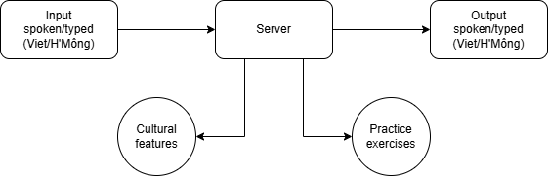
Description.
    - Design idea: Create a user-friendly, intelligent digital dictionary and translation app that can translate both directions between the H'Mông language and Vietnamese. The app supports both spoken (voice) and written (text) inputs and outputs. The ultimate goal is to enhance cross-cultural communication, preserve endangered indigenous knowledge, and promote the H'Mông cultural heritage in a digital era. It functions similarly to apps like Google Translate or TFlat, but with a focus on the unique grammar, phonetics, and cultural expressions of the H'Mông language.
    - Simple digital diagram: A visual diagram includes input methods (voice/text), processing (speech-to-text, translation, text-to-speech), and output (display/speak result). It also includes optional features like cultural content, dictionary mode, and offline access.
Design specification.
    - Three main approaches:
      - Community engagement: Collaborate with H'Mông elders, teachers, and cultural experts to collect traditional stories, idioms, songs, conversations, and historical documents.
      - Linguistic database building: Develop a structured bilingual dictionary containing basic words, grammar rules, slang, idioms, and commonly used phrases, organized by topic and frequency of use.
      - Authentic audio collection: Record and store real voices from different H'Mông dialect regions to reflect tonal variations, pronunciations, and regional diversity.
    - Technologies for each approach:
      - Voice-to-text (STT): Converts spoken H'Mông/Vietnamese to text using cloud services or open-source tools.
      - Text-to-speech (TTS): Outputs the translated text using natural-sounding voices.
      - Neural Machine Translation (NMT) system: Learns to translate from real usage and parallel data, with contextual understanding.
    - Devices required:
      - Mobile phones / tablets / computers: Provide access for users to interact with the app.
      - Microphones / field recorders: Capture native audio samples in various environments.
      - Cloud servers / local servers: Store large datasets, translations, and support real-time app services.
- Technologies.
    - Speech Recognition: Use Google Speech-to-Text, Mozilla DeepSpeech, or Whisper by OpenAI to handle multiple dialects and accents.
    - Database Management: Use MongoDB or MySQL to manage a bilingual dictionary, user accounts, progress tracking, and cultural content.
    - Translation Engine: Use AI/ML techniques like sequence-to-sequence models (Seq2Seq), transformer models, or transfer learning from low-resource languages.
    - App Development Tools:
      - Frontend: Flutter or React Native for responsive cross-platform design.
      - Backend: Node.js, Django, or Firebase for managing data flow.
      - Offline support: SQLite or local JSON files embedded within the app for use without the Internet.
- Functionality.
    - Input phase: A user can speak or type a sentence in either Vietnamese or H'Mông.
    - Processing phase:
      - Voice input is converted to text using STT.
      - Text is processed by the translation engine.
    - Output phase:
      - The translated text is shown on-screen.
      - Optionally, it is read aloud using TTS.
      - Cultural or usage notes may be displayed as tips or visuals.
    - Optional features:
      - “Explore Culture” mode with stories, folklore, pronunciation practice, and mini-games.
      - “Practice Mode” for learners with quizzes, flashcards, and pronunciation feedback.
Benefits:
    - Educational value: Helps H'Mông youth improve Vietnamese or preserve their own language; assists Vietnamese people in learning H'Mông.
    - Cultural preservation: Digitally documents oral traditions, proverbs, and songs that are in danger of fading.
    - Accessibility: Designed for both literate and low-literacy users; includes audio, icons, and offline capability.
    - Practical use: Aids in daily life communication (e.g., in hospitals, markets, or schools), making it useful for healthcare, tourism, education, and community services.
- Community impacts.
    - Social inclusion: Reduces language barriers between H'Mông and Kinh communities, fostering respect and mutual understanding.
    - Empowerment: Gives the H'Mông people digital tools to preserve, teach, and celebrate their language.
    - Support for researchers and educators: Enables field linguists, historians, and students to access structured data and native pronunciation.
    - Tourism and outreach: Promotes cultural tourism and engagement through real stories and interactive content.
- Appropriateness.
    - Ethical design: Developed with H'Mông people, not just for them. Involves consultations, consent, and co-creation.
    - Visual-first and audio-first interface: Uses symbols, images, and spoken guides to accommodate all literacy levels.
    - Offline mode: Essential for mountainous areas with limited connectivity.
    - Free and open access: Promotes equity by allowing anyone to download and use the app without cost.
    - Eco-friendly: Replaces printed dictionaries and materials with a fully digital alternative.
    - Economic benefit: Generates local employment through participation in content creation, validation, and app testing.
Constraints:
    - Dialect diversity: The H'Mông language has multiple dialects (e.g., White H'Mông, Green H'Mông) which may differ significantly in pronunciation and vocabulary, complicating standardization.
    - Data scarcity: Few existing resources on H'Mông make AI training challenging.
    - Technical limitations: Offline functionality may reduce accuracy and features.
    - Cultural sensitivity: Certain traditional knowledge may be sacred or private, requiring careful handling and permission.
    - Infrastructure gaps: Limited access to smartphones or reliable electricity in some communities.

3.4. Design Idea 4: Cultural exposure through media and education
- Team Member: Do Khac Phi
- Drawing:

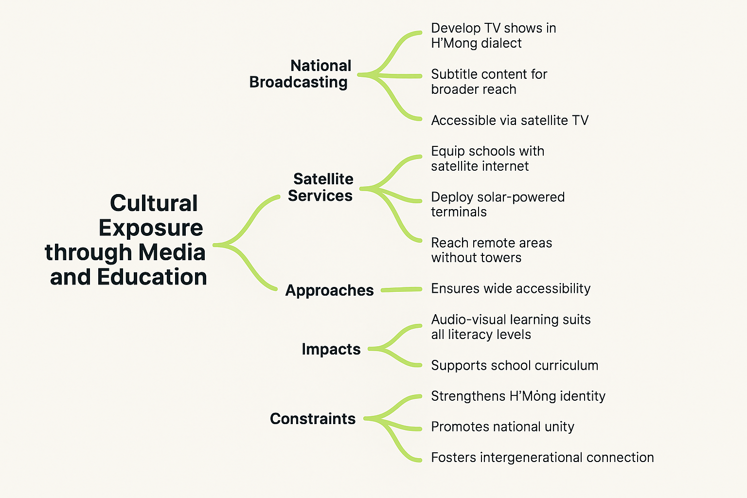
Approaches:

Cultural TV Programs: A weekly show aired on national and local channels can showcase the richness of H’Mông customs, such as weddings, the Gầu Tào festival, or the khèn instrument. Each episode could center around a theme like music, medicine, ritual, or food, and involve real community members and elders telling their stories.

Satellite E-Classes: These would deliver structured H’Mông cultural education to remote schools. Lessons could be led by trained cultural teachers or elders and might include storytelling, crafts, or language. Additional activities like drawing H’Mông symbols or interviewing family elders could be integrated into school assignments.

Mobile Culture Vans: In addition to TV and satellite classes, mobile vans equipped with satellite screens and speakers can travel to remote villages to screen H’Mông cultural content. These vans can also distribute printed materials, DVDs, or even hold small community workshops on traditional music, weaving, or farming rituals. This ensures hands-on exposure and participation in areas not covered by schools or media infrastructure.

Benefits:

Satellite television and national broadcasting provide several key benefits in the battle to preserve H'Mông cultural heritage.

First, the combination of national TV and satellite: viewing ensures that both urban and rural societies gain access to H'Mông programming. This overcomes infrastructure hurdles in mountainous areas like Hà Giang, where internet access is likely to be poor. Satellite and broadcast programming operate even when there is low connectivity, therefore being most appropriate to low-barrier cultural access.

In addition, visual and audio content: such as music, narrative, and indigenous performance, allow learning to be inclusive and accessible at various ages and literacy levels.

Such content online can also be helpful to educators by providing systematic cultural content that is coordinated with the school curriculum, therefore enhancing education in formal and informal learning environments.
Impacts:

Their impacts are social and cultural. What it achieves on the community level is to heighten H'Mông pride and identity through giving future generations meaningful access to their heritage.

On the national level: the showcasing of H'Mông rituals, crafts, and languages through TV and media helps to raise awareness regarding the ethnic diversity of Vietnam. This reduces cultural erosion and promotes respect among the different cultural groups.

At a worldwide scale: other ethnic group students benefit from exposure to minority cultures, strengthening national unity and integration within the education system and media.
- Cultural preservation: Involving the elderly in content creation through interviewing and teaching also serves to strengthen intergenerational relationships, familiarizing cultural bearers as known teachers and mentors it strengthened the intergenerational relationships.
Constraints:

Though the strengths are mentioned, there are constraints to the strategy.

Cost: is a major obstacle: purchasing and upkeep of satellite hardware, producing high-quality video content, and paying teachers all require long-term capital. Without guaranteed support from the government or NGOs, most rural towns cannot afford to have such infrastructure.

Lack of trained professionals: teachers and content producers need training in technical as well as cultural competence in creating engaging and correct content. Finally, cultural sensitivity is crucial. If H'Mông culture is misunderstood, be it through oversimplification or neglecting to consult with locals, it could lead to misinformation or loss of faith. Therefore, local participation is crucial at every step to ensure that the conservation process remains sustainable and respectful.

3.5. Design Idea 5: Preserving HMong Culture Through Digital Storytelling
- Team Member: Nguyen Dang Tuan Minh
Description
The cultural heritage of the Hmong people in Ha Giang is under threat from modernization which places the youth's cultural identity at risk (Văn Hoá Của Người Mông và Việc Bảo Tồn Các Giá Trị Văn Hoá Truyền Thống Của Dân Tộc Mông Trên Địa Bàn Tỉnh Hà Giang, 2023). Acknowledging this issue, the project suggests "Preserving HMong Culture Through Digital Storytelling". This initiative aims to create a multimedia platform to document, preserve, and share the HMong people’s cultural heritage, including folk songs, music, and rituals.
The project aims to develop a practical, community-centered multimedia platform that encourages the Hmong community, particularly youth, to actively protect their cultural heritage. It is not only about recording, but seeks to establish a living archive that can facilitate engagement and continuing education. In planning the platform, the four primary technological principles the platform's design is based on were accessibility, user-friendly, and emphasizes addressing the specific needs of the communities the platform is intended to support in Ha Giang.
- Drawing:
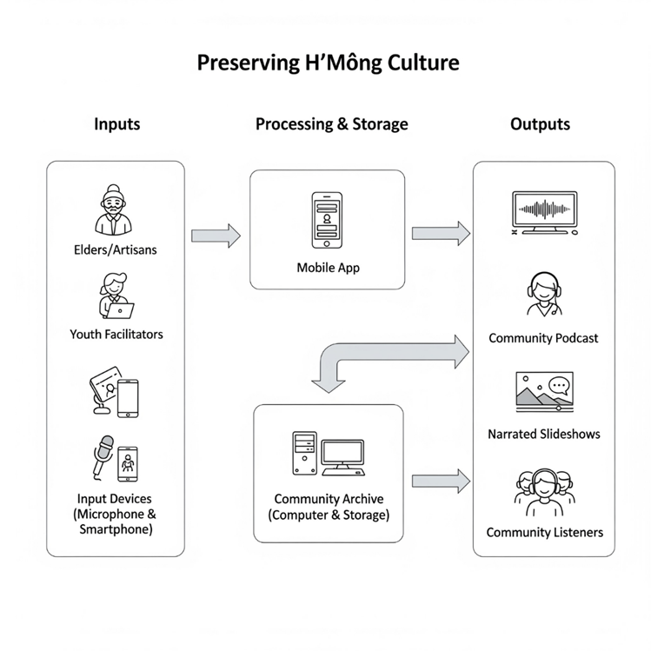
Design Specifications
Approach 1: Community-Led Cultural Documentation
This approach ensures the preservation of cultural heritage within communities by using two main technological tools. The first tool is a Voice & Song Recording App, which will be created to record oral histories as well as major folk songs, considered critical expressions of HMong culture (Minh, 2020). The mobile application will feature a simple bilingual interface (HMong and Vietnamese) and offline capacity to deal with issues of internet and subtitle. The second tool, an Ambient Sound + Soundscape Recorder, will allow the sound environment of festivals such as the Gầu Tào festival to be recorded to create a contextually authentic and immersive recording (Độc Đáo Lễ Hội Gầu Tào Của Đồng Bào Mông ở Hà Giang, 2024).
- Hardware Requirements: Mobile devices, wireless microphones, and mini tripods for stable recording, and SD cards or USB drives for saving files in offline situations.
- Software Requirements: A custom-developed recording application for mobile devices.
Approach 2: Digital Storytelling and Immersive Learning
This approach emphasizes turning collected materials into interesting stories. The Narrated Slideshow Documentation tool will allow users to combine annotated photos with ambient sounds and narrative explanations, creating step-by-step, respectful guides to complex rituals. Complementing this is a Community Podcast/Radio Builder, a simple software tool for creating audio programs like "grandma's stories" or interviews with elders. This material could be transferred locally via Bluetooth or SD cards and then uploaded online when there is a connection.
- Hardware Requirements: Computers or smartphones for editing, and child-friendly headphones for schools and community centers.
- Software Requirements: Simple slideshow and podcast/audio editing applications that use templates and are easy to use.
Approach 3: Ethical Dissemination and Intergenerational Engagement
This approach addresses the critical aspects of ethical sharing and connecting elders with youth. It is centered on an ethical framework rather than a single technology. Through community consultation, clear criteria will distinguish between public content and sacred knowledge reserved for the community. The platform will involve internal consent mechanisms whenever humans are involved in any visual or audio recording. To help lessen the technology-access gap, we will open community-based equipment centers and offer continuous training workshops. In-service training will teach HMong youth to assist older people with recording their stories and will also facilitate conversations and stories aligned with the youth's use of digital media to share their community's stories (Trần Hòa, 2024).
- How the design works: The workflow is initiated when community members take community-based materials and tools to collect cultural data. This cultural data is converted to digital stories, audio files, and soundscapes. The materials are placed in a digital archive and remain accessible to the community - virtually and physically - for integration into educational initiatives and cultural practices. The result is an established cycle of preservation and participation.
Benefits of design idea
This project offers enormous benefits through creating a living archive of oral heritage, at the same time supporting the preservation of the threatened HMong language. Crucially, it promotes intergenerational relations through empowering HMong young people to become active participants in their culture instead of passive recipients (Trần Hòa, 2024). The community impacts are significant, fostering a renewed sense of pride in HMong identity on both local and global stages, a key provincial goal (Bảo Tồn, Phát Huy Bản Sắc Văn Hóa Dân Tộc Mông, 2023). It will also promote authentic youth participation in cultural life. The community-based approach is also scalable and adaptable, serving different ethnic groups facing similar challenges.
Culturally, the design is essentially appropriate, as it is founded on community ownership and control. Prior approval and consent will address many cultural sensitivities. The project also supports significant development principles related (in terms of tech) to access and equity in providing affordable technology, and sustainable livelihoods through possible cultural tourism.
Constraints of design idea
Even with its potential, there are some limitations to the project. One limitation is the cultural and social acceptability of sharing certain rituals. Many ceremonies are seen as sacred and not for public consumption (Độc Đáo Lễ Hội Gầu Tào Của Đồng Bào Mông ở Hà Giang, 2024). Gaining the informed consent of the community, notably the elders, is likely to be a slow, tentative process that requires a respectful approach.
A second limitation is the technological barrier for community members, in particular elders, who may not be totally comfortable with certain digital devices, and there will be success depending on extensive training and the ability of young facilitators to tolerate the participants' misunderstandings. Finally, the initial investment of money to buy equipment and make custom applications is a big barrier. Proper funding is necessary to start the project on a strong footing and sustainability is needed to keep the project alive.

3.6. Design Idea 6: 3D Scanning and Preservation of H'Mông cultural assets
Team Member: Vu Huy Chris - SWH02350 - 10555004105550047

I. Description
“The 3D Scanning and Preservation of H’Mông cultural assets” program offers a comprehensive, digital 3D record of H’Mông township's tangible heritage—traditional houses ("Nhà Trình Tường"), ancestral altars, physical artifacts (e.g. stone reliefs), tools, fabrics, and landscapes (e.g. terraced rice fields) in Hà Giang. By creating high-fidelity digital 3D models stored in digital repositories, the project is dedicated to conservation, restoration, community education, and virtual tourism, ensuring these irreplaceable objects of much cultural significance continue to live on in the face of environmental loss or modernization.

Drawing (Below)
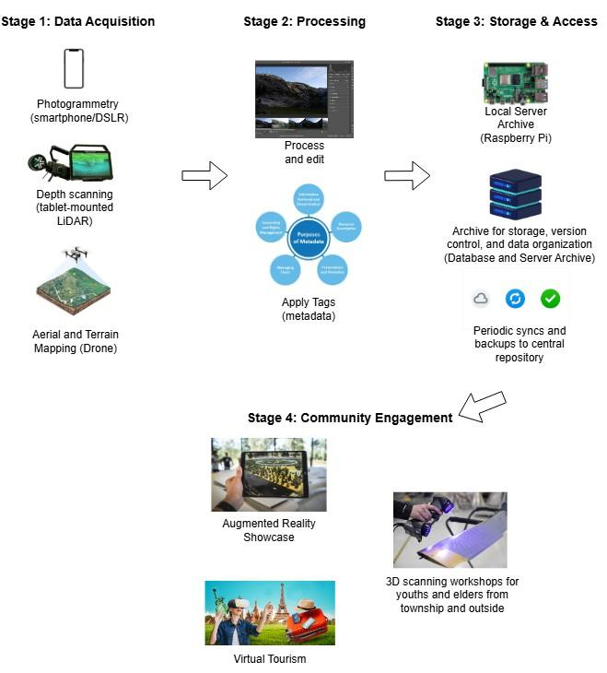
3D Scanning Program image

Design Idea Description:
This design idea covers 4 main stages consisting of Data Acquisition, Processing, Storage & Access and Community Engagement as seen in the image above.

Stage 1: Data Acquisition
Using publicly available devices and utilities, we can capture data for 3D models for a wide range of tangible assets.
- Photogrammetry (smartphone/DSLR):
Method: Image-based 3D reconstruction from overlapping smartphone or DSLR photos.
Using smartphones, local teams capture overlapping images of houses, tools, and textiles to cover every surface. (Khalloufi et al., 2020).
- Depth Scanning (tablet‑mounted LiDAR):
Method: Uses LiDAR or structured-light sensors on tablets to enrich geometric detail, especially in shaded or indoor areas.
Tablets with LiDAR sensors, such as those in the iPad Pro, have been shown to record detailed indoor structural features—including carvings and shrine interiors—with high precision comparable to terrestrial scans (Vacca, 2023; Teo & Yang, 2023).
- Aerial & Terrain Mapping (drone):
Method: Surveys larger areas like terraces, groves, stone field with consistent overlap for landscape-scale reconstruction.
A UAV-based survey using Structure-from-Motion photogrammetry and high image overlap successfully achieved sub-decimetre terrain modeling accuracy in complex upland environments, validating the method for landscape-scale erosion and terrain monitoring (Glendell et al., 2017).

Stage 2: Processing
- Process and Edit:
Using Meshroom (AliceVision), photogrammetry images and LiDAR/depth scans are processed into high-fidelity textured meshes. Photographs are first converted to point clouds, which are then meshed and textured to generate 3D models (Griwodz et al., 2023).
Models are imported into CloudCompare for noise filtering, outlier removal, and mesh optimization. This ensures accurate yet manageable file sizes for devices with low memory or limited GPU capacity (Santamaría-Hoyos et al., 2020).
- Contextual Tagging:
Metadata such as location (GPS), builder or artisan names, object function (ritual, daily use), and construction year is added using QGIS. This geospatial annotation allows advanced querying and spatial analysis of cultural patterns (Treccani et al., 2024).

Stage 3: Storage & Access
This stage allows the safekeeping of 3d models and data so that information is not lost to time, and that monitoring changes and understanding them is possible.
- Local Archive: A Raspberry Pi server hosts an offline‑first web portal for versioned 3D models. This enables community access through local Wi-Fi, even in low-connectivity regions. (Khalloufi et al., 2020)
- Database: Structured data storage and retrieval (e.g., versioning, categorization, metadata).
- Periodic Sync: When internet is available, models back up to a provincial repository, ensuring long‑term preservation. (FADGI, 2018)

Stage 4: Community Engagement
- Open-source frameworks like A‑Frame are increasingly used to develop accessible, browser-based 3D environments for cultural heritage engagement, supporting both immersive and remote exploration (Rubio-Tamayo, 2024).
- Mobile AR applications such as LagunAR enable on-site heritage interpretation by overlaying 3D models onto real-world environments through smartphones and tablets (Sánchez Berriel et al., 2023).
- Workshops: Youth and elders co‑host scanning and annotation sessions, fostering intergenerational knowledge transfer. (Khalloufi et al., 2020)

II. Design Specifications

Approach: Analyse
Technology: Photogrammetry, Aerial Imaging (Mapping), Depth Scanning, Reconstruction Software

Devices: Smartphones, Drone, Tablets with LiDAR
Accessibility in utilities ensures scalable and repeatable documentation using existing personal devices. Moreover, 3D scans, re-scans and model version archives allow the tracking of geometry and material changes over time, providing objective degradation metrics and understanding what affects the object.
As such, this helps with the analysis of the scanned assets in different ways, such as observing them from different perspectives, comparing to other communities' cultural equivalence, checking what changes and what is not,....

Approach: Prevent
Technology: Depth Scanning and Aerial Imaging (Mapping)
Devices: Tablet with LiDAR, Drone
The LiDAR system helps detect subtle deformations or structural weaknesses, enabling early preventive interventions.
As for Aerial Imaging, the analysis of the geography and climate allows detection of environmental changes that may affect the heritages, specifically structures and artifacts like stone reliefs, allowing preventive measures to come in and prevent its loss.

Approach: Eliminate
Technology: Photogrammetry, Aerial Imaging (Mapping), Depth Scanning
Devices: Smartphones, Drone, Tablets with LiDAR
With these technologies covering each other’s weakness in 3D scanning, we’re able to store most definite and high fidelity data that otherwise would have been lost to time, erosion and other factors.

Hardware & Software Requirements
Acquisition Devices
- Smartphone (≥12 MP, 4 GB RAM): Employed successfully in smartphone-based videogrammetry for detailed heritage models, achieving accuracy comparable to DSLRs and laser scanners (Musicco et al., 2023; Murtiyoso & Grussenmeyer, 2021).
- Tablet with LiDAR (e.g., iPad Pro + Structure Sensor): Proven effective for indoor architectural heritage scans, accurately capturing interior dimensions and textures (Vacca, 2023).
- Drone (GPS-enabled, e.g., DJI Mini): Used in UAV photogrammetry for terrain and erosion modeling in cultural heritage sites, providing high-resolution DEMs (Glendell et al., 2017).
Processing Workstation
- PC: Intel i5 or Ryzen 5, 16 GB RAM, SSD—matched the requirements of open-source photogrammetry workflows (Paukkonen, 2023).
- Meshroom / COLMAP: Utilized for creating dense meshes from heritage imagery (Paukkonen, 2023).
- CloudCompare: Employed in complex heritage site modeling for noise filtering and mesh improvement (Abate et al., 2025)
Storage & Access Infrastructure
- Raspberry Pi 4 + 1 TB HDD: No proven document specifically mention such requirement, but looking at how data heavy 3D models can be, this is a general requirement metric that is decent enough for initial testing and not too difficult for obtaining.
Engagement Platforms
- Cloud-based platforms hosting 360° heritage tours have proven effective at enabling global access to cultural sites via standard web browsers (Research in Scientific Advances and Applications, 2024).

III. Benefits of design idea

Benefit 1: Comprehensive Physical Heritage Record
Captures both tangible (architecture, tools, textiles) assets in a unified digital archive.
Smartphone and drone photogrammetry have been successfully used together to document entire heritage sites in high fidelity (Musicco et al., 2023).

Benefit 2: Restoration & Research Foundation
Provides accurate geometric and contextual data for future restoration projects, academic studies, and virtual exhibitions.
Asadpour (2021) demonstrated that smartphone photogrammetry produced high-resolution 3D data used effectively in restoration planning of historical monuments.
Musicco et al. (2023) showcased how combined videogrammetry and UAV photogrammetry yielded precise geometric and contextual datasets for in-depth heritage analysis and scholarly studies.

Benefit 3: Resilience Against Loss
Mitigates risks from environmental decay, modernization, or shifting land use by preserving high-detail records of cultural assets over time.
Pennanen (2023) used multi-temporal drone photogrammetry to monitor erosion in heritage landscapes, enabling preemptive conservation responses.
Vacca (2023) demonstrated precise LiDAR scans of heritage interiors which form critical baselines to detect and manage structural degradation over time.

Benefit 4: Virtual Tourism
Virtual experiences reduce wear on physical sites while supporting cultural tourism.

IV. Constraints of design idea

Constraint 1: Technical Training Requirements
Local teams must learn photogrammetry, LiDAR scanning, and processing workflows—a time- and resource-intensive process that often requires ongoing mentorship and structured workshops.
Conservation experts highlight that effective photogrammetry demands skill in both data capture and analysis, making training essential (Lerma et al., 2013).

Constraint 2: Data Management Complexity
Handling large volumes of high-resolution 3D models demands reliable local storage, version control, and well managed periodic backups.
3D heritage archiving research emphasizes the importance of version-controlled, FAIR-compliant infrastructures due to the large file sizes and diverse usage contexts (Deidda et al., 2019; Barzaghi et al., 2024).

Constraint 3: Cultural Sensitivity & Permissions
Recording sacred sites or rituals requires navigating local protocols, obtaining community consent, and respecting restrictions on access and distribution
Ethical frameworks underscore that heritage digitization with indigenous communities requires long-term trust-building, informed consent, and compliance with community protocols, especially for sacred or culturally restricted materials (Csoba DeHass et al., 2024; Barlo et al., 2020).

References
General Statistics Office of Vietnam. (2019). 2019 Vietnam Population and Housing census. https://www.gso.gov.vn/wp-content/uploads/2019/12/Ket-qua-toan-bo-Tong-dieu-tra-dan-so-va-nha-o-2019.pdf
Biradar, S. S. (2024). Revitalizing Indigenous tourism: Challenges and opportunities. ShodhKosh: Journal of Visual and Performing Arts, 5(3), 1226–1231. https://doi.org/10.29121/shodhkosh.v5.i3.2024.4170
Worldpackers. (2025, April 24). Eco-friendly accommodations. https://www.worldpackers.com/articles/eco-friendly-accommodations
Tran, R. (2021, February 19). Hmong houses on Dong Van rocks. Vietnam Discovery. https://vietnamdiscovery.com/ha-giang/attractions/hmong-houses-on-dong-van-rocks/
Gall, J. (2018, April 10). The benefits of community-owned renewable energy projects. University of Saskatchewan. https://renewableenergy.usask.ca/news-articles/the-benefits-of-community-owned-renewable-energy-projects.php
Trinh, T. T. T. A., Trinh, T. T. L. A., & Thanh, N. N. (2023, September). The impact of green tourism on the Hmong community in Vietnam. Multidisciplinary Science Journal, 6(4). https://doi.org/10.31893/multiscience.2024034
UN Tourism (UNWTO). (2024, December 12). Tourism as a driver of rural empowerment: UN Tourism Global Conference concludes in Viet Nam. https://www.unwto.org/news/tourism-as-a-driver-of-rural-empowerment-un-tourism-global-conference-concludes-in-viet-nam
Voanh, N. T. K. (2017, February 24). An overview of the culture of the H’Mông ethnic group in Vietnam. Vietnam Women’s Museum. https://baotangphunu.com/vai-net-ve-van-hoa-cua-dan-toc-hmong-o-viet-nam/
Anh, M. (2024, August 1). Ensuring digital technology access rights for the people. Nhân Dân Online Newspaper.
https://nhandan.vn/bao-dam-quyen-tiep-can-cong-nghe-so-cho-nguoi-dan-post822233.html
Anh, N. (2022, April 22). The beauty in the customs and cultural practices of the H’Mông people. Ethnic Affairs and Development Newspaper.
https://baodantoc.vn/net-dep-trong-phong-tuc-tap-quan-van-hoa-cua-nguoi-mong-1650622165522.htm
Minh, H. (2020, February 11). Dân ca là tiếng lòng của người Mông gửi gắm qua câu hát. Báo Dân Tộc và Phát Triển; baodantoc.vn. https://baodantoc.vn/dan-ca-dan-toc-mong-va-noi-tran-tro-cua-nghe-nhan-1581356505981.htm
Bảo tồn, phát huy bản sắc văn hóa dân tộc Mông. (2023). Baohagiang.vn. https://baohagiang.vn/van-hoa/202310/bao-ton-phat-huy-ban-sac-van-hoa-dan-toc-mong-c6f3322/
Văn hoá của người Mông và việc bảo tồn các giá trị văn hoá truyền thống của dân tộc Mông trên địa bàn tỉnh Hà Giang. (2023, August 16). Hagiang.gov.vn. https://hagiang.gov.vn/lich-su-van-hoa/van-hoa-cua-nguoi-mong-va-viec-bao-ton-cac-gia-tri-van-hoa-truyen-thong-cua-dan-toc-mong-tren-di-269274

Độc đáo lễ hội Gầu Tào của đồng bào Mông ở Hà Giang. (2024). Hagiangtv.vn. https://hagiangtv.vn/doi-song-xa-hoi/202402/doc-dao-le-hoi-gau-tao-cua-dong-bao-mong-o-ha-giang-9a10c08/
Trần Hòa. (2024, June 18). Người trẻ “đạp gió cưỡi mây” kể chuyện dân tộc Mông. Báo Giáo Dục và Thời Đại Online. https://giaoducthoidai.vn/nguoi-tre-dap-gio-cuoi-may-ke-chuyen-dan-toc-mong-post687811.html
Ye, X., Ruan, Y., Xia, S., & Gu, L. (2025). Adoption of digital intangible cultural heritage: a configurational study integrating UTAUT2 and immersion theory. Humanities and Social Sciences Communications, 12(1). https://doi.org/10.1057/s41599-024-04222-8
Ziku, M. (2020). Digital Cultural Heritage and Linked Data: Semantically-informed conceptualisations and practices with a focus on intangible cultural heritage. LIBER Quarterly, 30(1), 1. https://doi.org/10.18352/lq.10315
Lin, P., & Sharudin, S. A. B. (2024). Application of Hmong Painting Patterns to Batik Motifs Design in Anshun, Guizhou, China. South Asian Journal of Social Sciences and Humanities, 5(3), 176–195. https://doi.org/10.48165/sajssh.2024.5310

3.6’s Citation Table:
Khalloufi, H., Azough, A., Ennahnahi, N., & Kaghat, F. Z. (2020). LOW-COST TERRESTRIAL PHOTOGRAMMETRY FOR 3D MODELING OF HISTORIC SITES: A CASE STUDY OF THE MARINIDS' ROYAL NECROPOLIS CITY OF FEZ, MOROCCO. https://doi.org/10.5281/zenodo.3930412
Maté-González, M. Á., Di Pietra, V., & Piras, M. (2022). Evaluation of different LiDAR technologies for the documentation of forgotten cultural heritage under forest environments. Sensors, 22(16), 6314. https://doi.org/10.3390/s22166314
Santamaría-Hoyos, N., Santamaría-Peña, J., Valle, J. M., & Sanz-Adán, F. (2020). 3D digitization of the archaeological and palaeontological heritage through non-contact low-cost scanners: Comparative analysis. In F. Cavas-Martínez, F. Sanz-Adán, P. Morer Camo, R. Lostado Lorza, & J. Santamaría Peña (Eds.), Advances in design engineering. INGEGRAF 2019 (Lecture Notes in Mechanical Engineering, pp. 571–579). Springer. https://doi.org/10.1007/978-3-030-41200-5_64
Federal Agencies Digital Guidelines Initiative. (2018). Technical Guidelines for Digitizing Cultural Heritage Materials. https://www.digitizationguidelines.gov
Lerma, José & Cabrelles, Miriam & Navarro, Santiago & Fabado, Santiago. (2013). From Digital Photography to Photogrammetry for Cultural Heritage Documentation and Dissemination. DISEGNARECON. 6. 10.6092/issn.1828-5961/3850.
Musicco, A., Rossi, N., & Verdoscia, C. (2023). Accuracy evaluation of smartphone-based videogrammetry for cultural heritage documentation process. International Archives of the Photogrammetry, Remote Sensing and Spatial Information Sciences, 48(XLVIII‑M‑2‑2023), 1119–1126. https://doi.org/10.5194/isprs-archives-XLVIII-M-2-2023-1119-2023

Murtiyoso, A., & Grussenmeyer, P. (2021). Experiments using smartphone-based videogrammetry for low-cost cultural heritage documentation. International Archives of the Photogrammetry, Remote Sensing and Spatial Information Sciences, 46(M-1), 487–491. https://doi.org/10.5194/isprs-archives-XLVI-M-1-2021-487-2021

Vacca, G. (2023). 3D survey with Apple LiDAR sensor—Test and assessment for architectural and cultural heritage. Heritage, 6(2), 1476–1501. https://doi.org/10.3390/heritage6020080

Glendell, Miriam & Mcshane, Gareth & Farrow, Luke & James, Mike & Quinton, John & Anderson, Karen & Evans, Martin & Benaud, Pia & Rawlins, Barry & Morgan, David & Jones, Lee & Kirkham, Matthew & DeBell, Leon & Quine, Timothy & Lark, Murray & Rickson, R. & Brazier, Richard. (2017). Testing the utility of structure from motion photogrammetry reconstructions using small unmanned aerial vehicles and ground photography to estimate the extent of upland soil erosion. Earth Surface Processes and Landforms. 42. 10.1002/esp.4142.

Sánchez Berriel, I., Pérez Nava, F., & Albertos, P. T. (2023). LagunAR: A City-Scale Mobile Outdoor Augmented Reality Application for Heritage Dissemination. Sensors, 23(21), 8905. https://doi.org/10.3390/s23218905

Rubio-Tamayo, Jose Luis. (2024). A-Frame as a prototyping tool for the design of immersive experiences in cultural heritage: towards an extended reality approach to interaction design.

Pennanen, K. (2023). Change detection analysis using drone‑based photogrammetry for long‑term archaeological site erosion monitoring. Canadian Journal of Archaeology, 47(1), 49–64. https://doi.org/10.51270/47.1.49

Glendell, Miriam & Mcshane, Gareth & Farrow, Luke & James, Mike & Quinton, John & Anderson, Karen & Evans, Martin & Benaud, Pia & Rawlins, Barry & Morgan, David & Jones, Lee & Kirkham, Matthew & DeBell, Leon & Quine, Timothy & Lark, Murray & Rickson, R. & Brazier, Richard. (2017). Testing the utility of structure from motion photogrammetry reconstructions using small unmanned aerial vehicles and ground photography to estimate the extent of upland soil erosion. Earth Surface Processes and Landforms. 42. 10.1002/esp.4142.
Rodríguez, J., Lamas, M. I., & Castro-Santos, L. (2025). Scientific Advances and Applications of 360 Tours in the XXI Century. Societies, 15(4), 74. https://doi.org/10.3390/soc15040074
Teo, T.-A., & Yang, C.-C. (2023). Evaluating the accuracy and quality of an iPad Pro’s built‑in LiDAR for 3D indoor mapping. Developments in the Built Environment, 100169. https://doi.org/10.1016/j.dibe.2023.100169
Teo, T., & Yang, C. (2023). Evaluating the accuracy and quality of an iPad Pro’s built-in lidar for 3D indoor mapping. Developments in the Built Environment, 14, 100169. https://doi.org/10.1016/j.dibe.2023.100169
Abate, N., Roubis, D., Aggeli, A. et al. An Open-Source Machine Learning–Based Methodological Approach for Processing High-Resolution UAS LiDAR Data in Archaeological Contexts: A Case Study from Epirus, Greece. J Archaeol Method Theory 32, 38 (2025). https://doi.org/10.1007/s10816-025-09706-8

